Keywords:QYB40-165L,Air operated oil pump
Beijing BPM,Beijing Petroleum Machinery Co.,Control System for Surface Mounted BOP Stacks, bop control unit, koomey unit, BPMF BOP CONTROL, accumulator unit, FKDQ1200-9,FKDQ1200-9B,FKDQ960-7,FKDQ640-7,FKQ1440-14,FKQ1200-9,FKQ1280-8,FKQ960-8,FKQ840-8,FKQ800-8,FKQ1280-7,FKQ1200-7,FKQ800-7D,FKQ800-7E,FKQ800-7F,FKQ800-8G,FKQ800-9H,FKQ640-7,FKQ800-6FFKQ720-6,FKQ640-6G,FKQ640-6,FKQ640-6M,FKQ640-6S,FKQ480-5,FKQ480-5C,FKQ480-5E,FKQ480-5B,FKQ480-5D,FKQ320-4B,FKQ3204E,FKQ320-4G,FKQ320-3,FKQ160-4W,FK250-4,FK240-4,FK160-4,FK100-4,FK240-3E,FKQ240-3D,FK240-3,FK125-3,FK125-3B,FK125-2D,FK125-2F,FK50-1

Product name:Air operated oil pump
Model:QYB40-165L
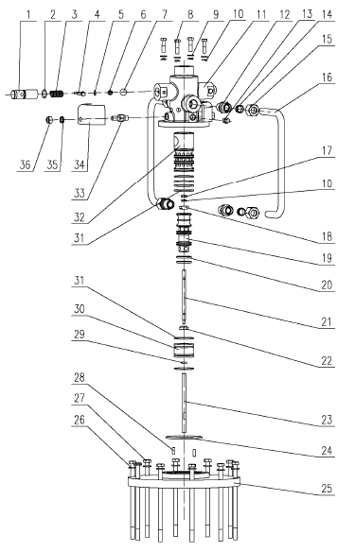
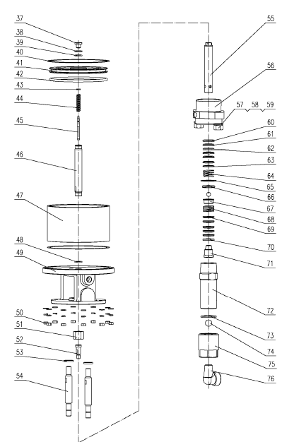
1 Locating sleeve 9163800018 2
2 O-ring seal 5303001010 2 17×2.65
3 Locating sleeve spring 9163800019 2
4 Hexagon fit bolts--Product 4202001820 2 M6×45
5 Standard spring washer 4205030030 2 6
6 Type I hex nut 4204000040 2 M6
7 Steel ball 4371010320 3 16.000
8 Hex bolt 4202000131 4 M8×30
9 Plain washer grade A 4205010040 4 8
10 Standard spring washer 4205030040 5 8
11 Pump head 9165200015 1
12 Gas pipe joint 9163800025 4
13 1/4 pipe plug 9180412000 2
14 Gas pipe gasket seal 9163800024 4
15 Gas pipe nut 9163800023 4
16 Gas pipe 9165200016 2
17 Hex nut 4204000260 1 M8 (DZn）
18 Spool connecting rod and baffle plate 9163800026 1
19 Spool 9163800028 1
20 O-ring seal 9163800043 2 31.2×3.65(聚氨酯)
21 Spool connecting rod 9163800027 1
22 Nut for spool connecting rod 9163800029 1
23 Spool rod 9163800033 1
24 O-ring seal 5303100050 1 85×2.65
25 Seat for pump head 9165200013 1
26 Plain washer grade A 4205010050 20 10
27 Hex bolt 4202001970 10 M10×190(DZn)
28 Parallel pins 4207010080 2 B6×20
29 O-ring seal 5303000950 1 10×2.65
30 Spool sleeve bracket 9163800030 1
31 O-ring seal 5303000160 6 45×2.65
32 Spool sleeve 9165200014 1
33 Pump head plug 9163800016 2
34 Gas baffle 9163800017 2
35 Standard spring washer 4205030050 12 10
36 Type I hex nut – fine thread 4204000150 2 M10×1
37 Piston rod screw cap 9163800031 1
38 Piston gasket 9163800032 1
39 O-ring seal 5303000070 1 22.4×3.55
40 Gasket seal for air cylinder 9165200009 2
41 Piston 9165200012 1
42 O-ring seal 5303101140 1 230×8.6
43 Stop collar for spool rod 9163800035 1
44 Spool rod spring 9163800036 1
45 Spool rod coupling 9163800034 1
46 Piston rod 9163800037 1
47 Air cylinder 9165200023 1
48 O-ring seal 5303001120 1 28×3.55
49 Base 9165200010 1
50 Type I hex nut 4204000060 10 M10
51 Piston rod nut 9163800009 1
52 Piston rod coupling 9165200017 1
53 Connecting rod gasket 9163800039 2
54 Extension rod for base 9165200018 2
55 Plunger rod 9165200007 1
56 Body 9165203000 1
57 Type I hex nut 4204000160 2 M20×1.5
58 Standard spring washer 4205030100 2 20
59 Plain washer grade A 4205010100 2 20
60 Pressure ring 9165202001 1
61 V-fabrics. ring gasket 9165201003 5
62 V-supplement ring gasket 9165201002 4
63 Support ring 9165202002 1
64 Body spring 9165200019 1
65 Spring stop collar 9165200020 1
66 Spring seat 9165200021 1
67 Plunger copper sleeve 9165200006 1
68 Plunger spring 9165200005 1
69 Support ring 9165201004 1
70 Pressure ring 9165201001 1
71 Pressure cap 9165200004 1
72 Plunger type cylinder 9165200003 1
73 Steel ball catch 9165200002 1
74 Steel ball 4371010150 1 25.400
75 Plunger piston coupling 9165200001 1
76 Male and female angle fittings 9180401000 1

