Keywords:Triplex pump,QB21-80,QB21-63,QB21-50,QB21-40
Beijing BPM,Beijing Petroleum Machinery Co.,Control System for Surface Mounted BOP Stacks, bop control unit, koomey unit, BPMF BOP CONTROL, accumulator unit, FKDQ1200-9,FKDQ1200-9B,FKDQ960-7,FKDQ640-7,FKQ1440-14,FKQ1200-9,FKQ1280-8,FKQ960-8,FKQ840-8,FKQ800-8,FKQ1280-7,FKQ1200-7,FKQ800-7D,FKQ800-7E,FKQ800-7F,FKQ800-8G,FKQ800-9H,FKQ640-7,FKQ800-6FFKQ720-6,FKQ640-6G,FKQ640-6,FKQ640-6M,FKQ640-6S,FKQ480-5,FKQ480-5C,FKQ480-5E,FKQ480-5B,FKQ480-5D,FKQ320-4B,FKQ3204E,FKQ320-4G,FKQ320-3,FKQ160-4W,FK250-4,FK240-4,FK160-4,FK100-4,FK240-3E,FKQ240-3D,FK240-3,FK125-3,FK125-3B,FK125-2D,FK125-2F,FK50-1

Product name:Triplex pump
Model:QB21-80,QB21-63,QB21-50,QB21-40
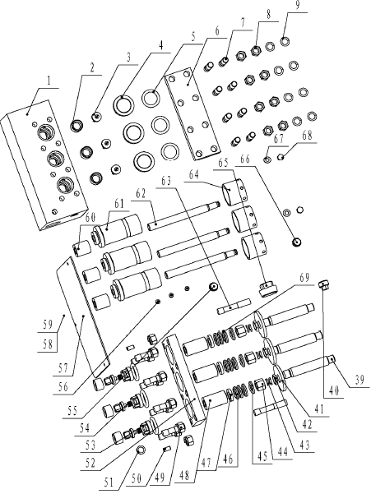
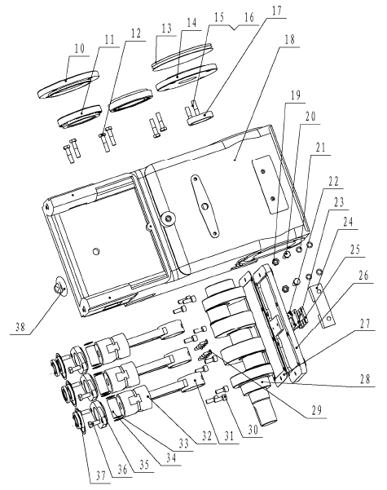
1 Pump head body 9160100002 1
2 Valve seat 9160100006 6
3 Oil inlet and outlet valve core 9160100005 6
4 Gland 9160100010 3
5 O-ring 5303001230 6 40×3.55
6 Clamp bar 1 9160100009 1
7 Stud bolt 4202100010 8 M16×50
8 Hexangular nut 4204000090 18 M16
9 Light Spring washer 4205030080 18 16
10 Bearing gland 9160200038 1
11 Cone roller bearing 4301000040 2 32016(2007116)
12 Hex screw 4202000420 4 M12×25
13 Red paper gasket 9160200039 8
14 Bearing gland 9160200041 1
15 Hex screw 4202000450 4 M12×40
16 Flat washer ring 4205010060 4 12
17 Skeleton sealing ring 5303930050 1 52×72×8
18 Casing 9160200001 1
19 Hexangular nut 4204000060 2 M10
20 Hexangular bolt 4202000260 2 M10×40
21 Spring washer 4205030050 4 10
22 Sealing gasket 9160200050 1
23 Window for oil sign 9160200052 1
24 Oil baffle 9160100030 1
25 Clamp bar for oil sign 9160200051 1
26 Cover plate 9160200034 1
27 Red paper gasket 9160100033 1
28 Crank shaft 9160200032 1
29 Cross groove-sunken screw 4201013130 8 M6×18
30 Hidden hex-cylinder top screw 4201120220 10 M10×25
31 Connecting rod 9160200028 3
32 Cross head 9160200027 3
33 Elastic retaining ring for hole 4206022040 6 d0=25
34 Rod 9160200026 3
35 Flange 9160100025 3
36 Hex end bolt 4202000230 6 M10×25
37 Skeleton sealing ring 5303930020 6 25×47×7
38 Lifting bolt 4201220020 1 M12
39 Crosshead shaft 9160100021 3
40 Screw plug 9160100042 1
41 Retaining flat 9160100022 3
42 Lock nut 9160100020 3
43 Retaining ring 9160100019 6
44 Tension bar nut 9160100018 3
45 V-textile modular sealing 9160399200 3 set QB 21-40，Oldstyle
9160399300 3 set QB 21-40，Kuai Ke
46 V-textile modular sealing 9160499200 3 set QB 21-63，Oldstyle
9160499300 3 set QB 21-63， Kuai Ke
47 V-textile modular sealing
9160599200 3 set QB 21-80，Oldstyle
9160599300 3 set QB 21-80， Kuai Ke
48
Packing ring 9160300012 3 QB 21-40
Packing ring 9160400012 3 QB 21-63
Packing ring 9160500012 3 QB 21-80
49 Stud bolt 4202100020 8 M16×60
50 Cylinder pin 4207010110 2 10×20
51 Sealing gasket 9160100047 1
52 Clamp bar 2 9160100013 1
53 Absorbing valve support 9160100003 3
54 Spring 9160100004 6
55 Screw plug 9160100040 1
56 Cross groove-dish top screw 4201012130 3 M6×16
57 Cover plate for pump 9160100036 1
58 Clamp bar 3 9160100023 3
59 Paper gasket 9160100024 3
60
Liner 9160300016 3 QB 21-40
Liner 9160400016 3 QB 21-63
Liner 9160500016 3 QB 21-80
61
Cylinder 9160300014 3 QB 21-40
Cylinder 9160400014 3 QB 21-63
Cylinder 9160500014 3 QB 21-80
62
Plunger 9160300015 3 QB 21-40
Plunger 9160400015 3 QB 21-63
Plunger 9160500015 3 QB 21-80
63 Stud bolt 4202100030 2 M16×80
64 Packing pressing cap 9160100017 3
65 Screw plug 9160100008 1
66 Air bleeding plug 9160100046 2
67 Hex top bolt 4202000210 2 M10×16
68 Flat washer ring 4205010050 2 10

